**iNeuron Power BI Assignment – 2**

* **Connect to the Store Sales Data and do the following: -** 
  + −  *Remove all the blank rows.*
  + −  *Update the column header if they are not updated*
  + −  *Create a text table and show the sales in terms of*

o *Customers*o *Product Category*

o *Regions*

***Connecting Store Sales Data***

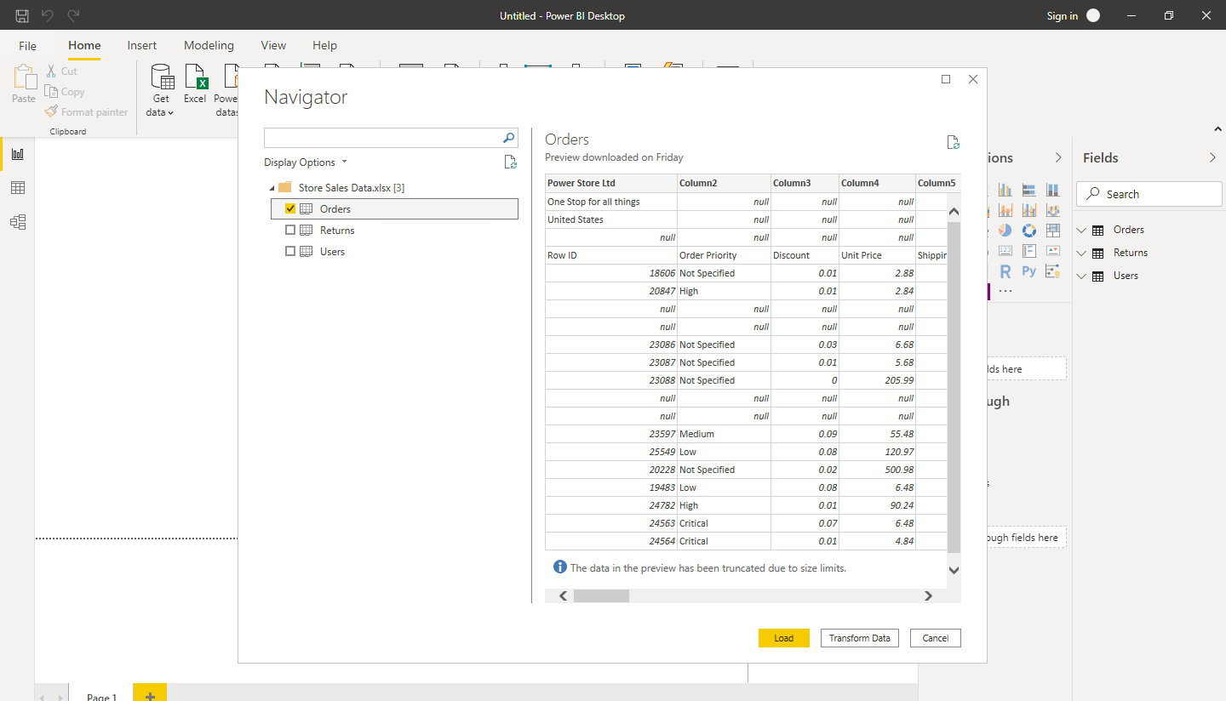

*Data taken into Power Query Editor.*

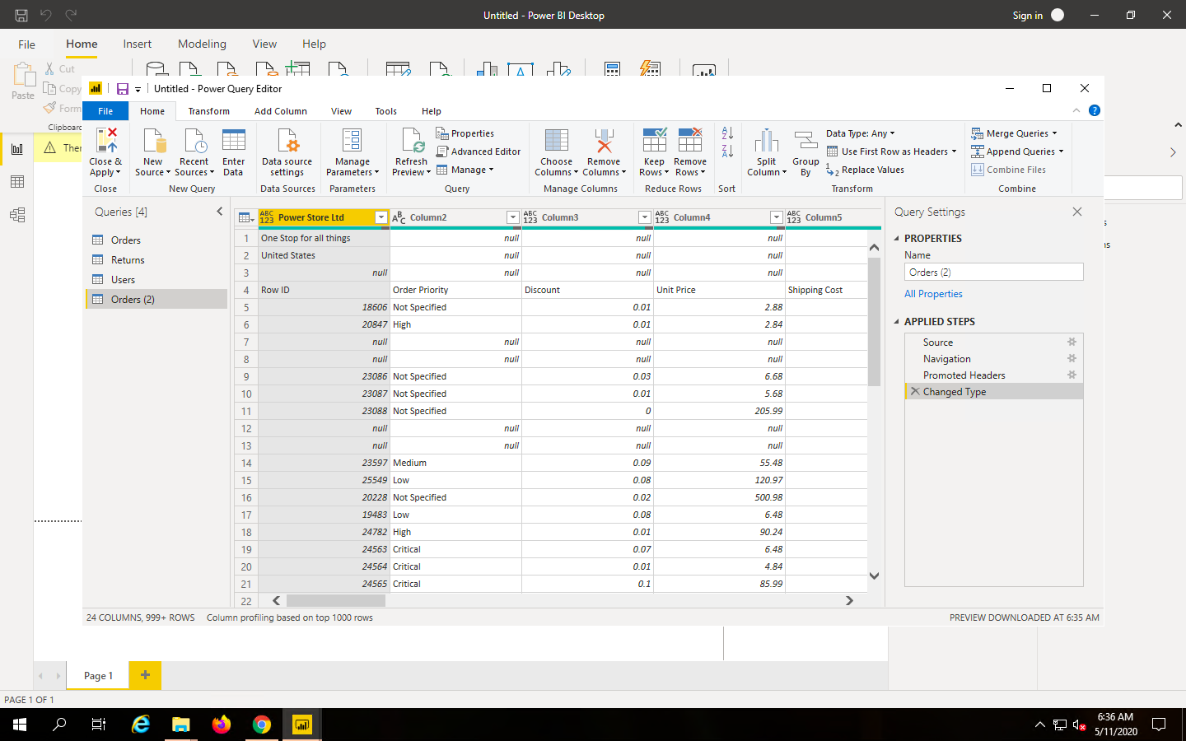

*Blank rows removed.*

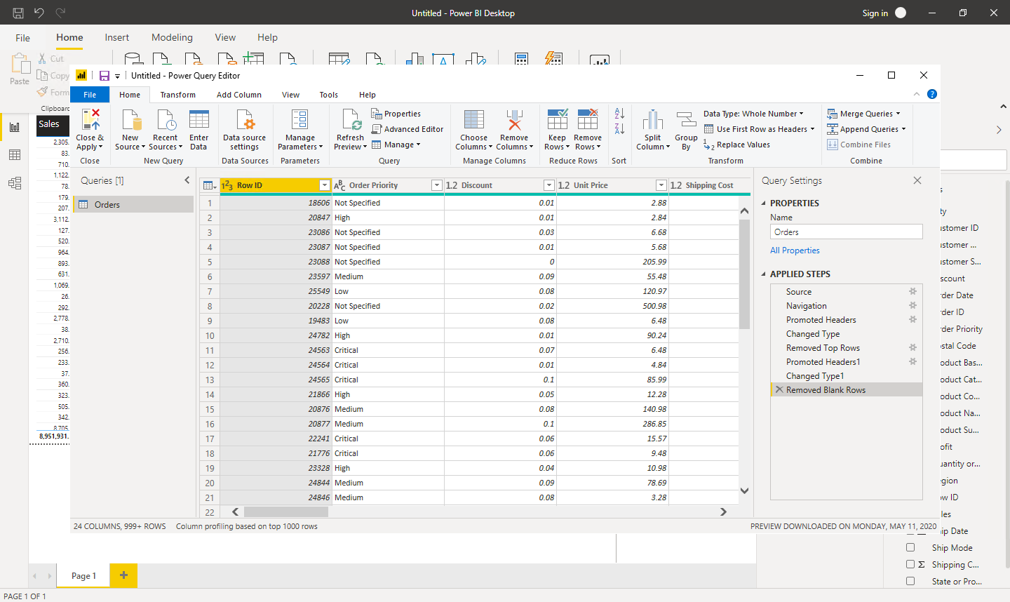

*Creation of text table with Customer Name, Product Category and Region.*

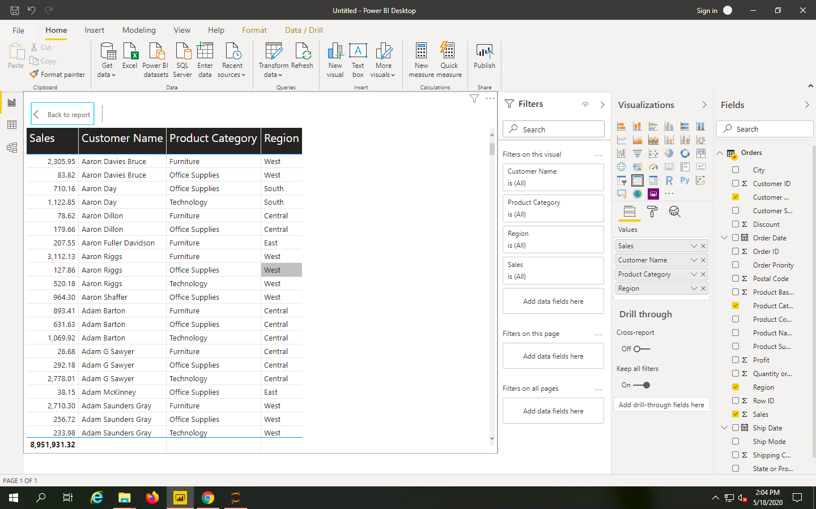

* **Create a line and Clustered Column Chart showing the Sales and Discount as per the State or Province** 
  + −  *Format the bars and line with different colors*
  + −  *Which state has the highest sales in terms Technology*

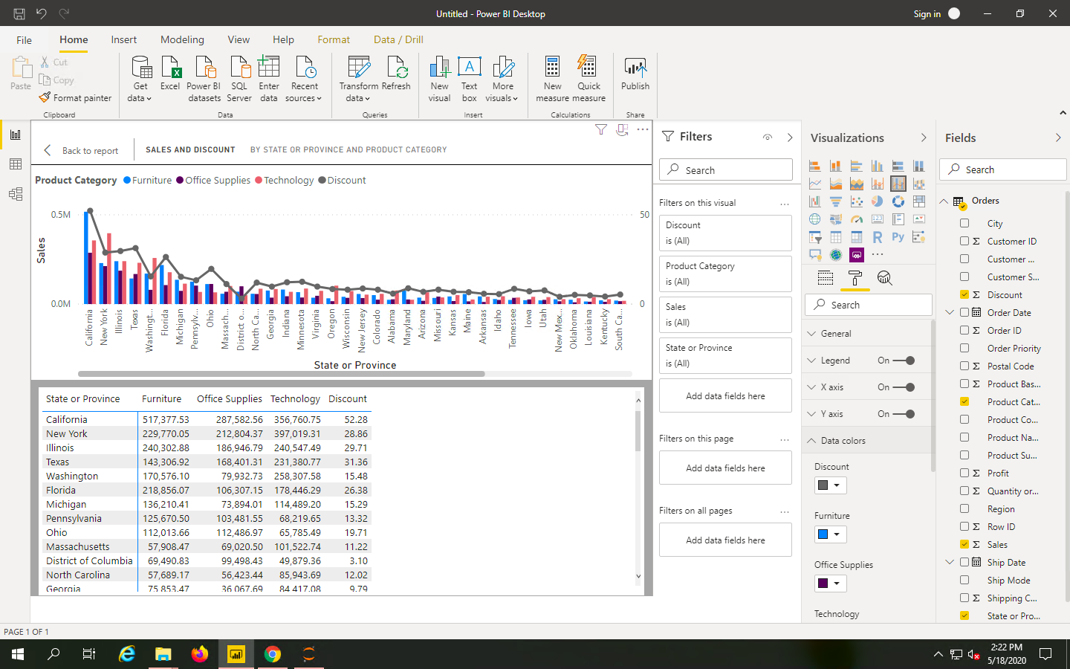New York has the highest sales in terms of Technology.

* **Create a** *Donut Chart* **showing sales in terms of Product category**

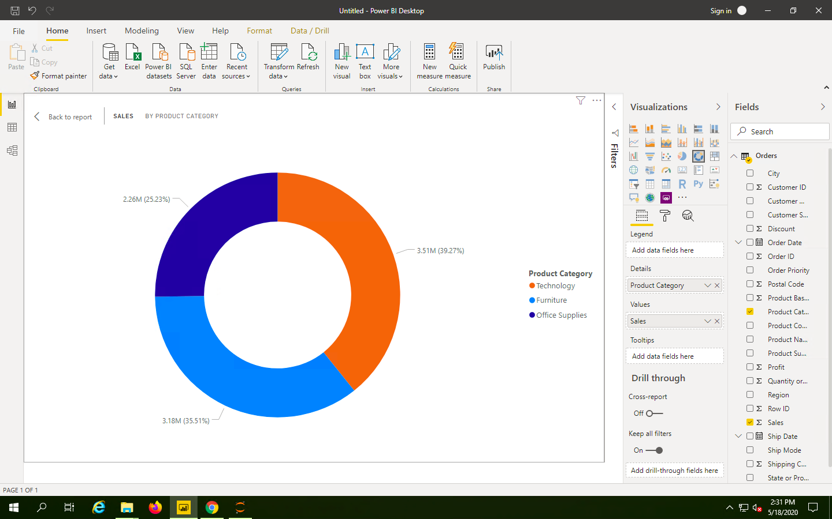

* **Create a** *Slicer* **and show the regions in dropdown. See how all the visuals mentioned above behaving when a particular region is selected.**

For Central region Illinois and Texas have the maximum sales.

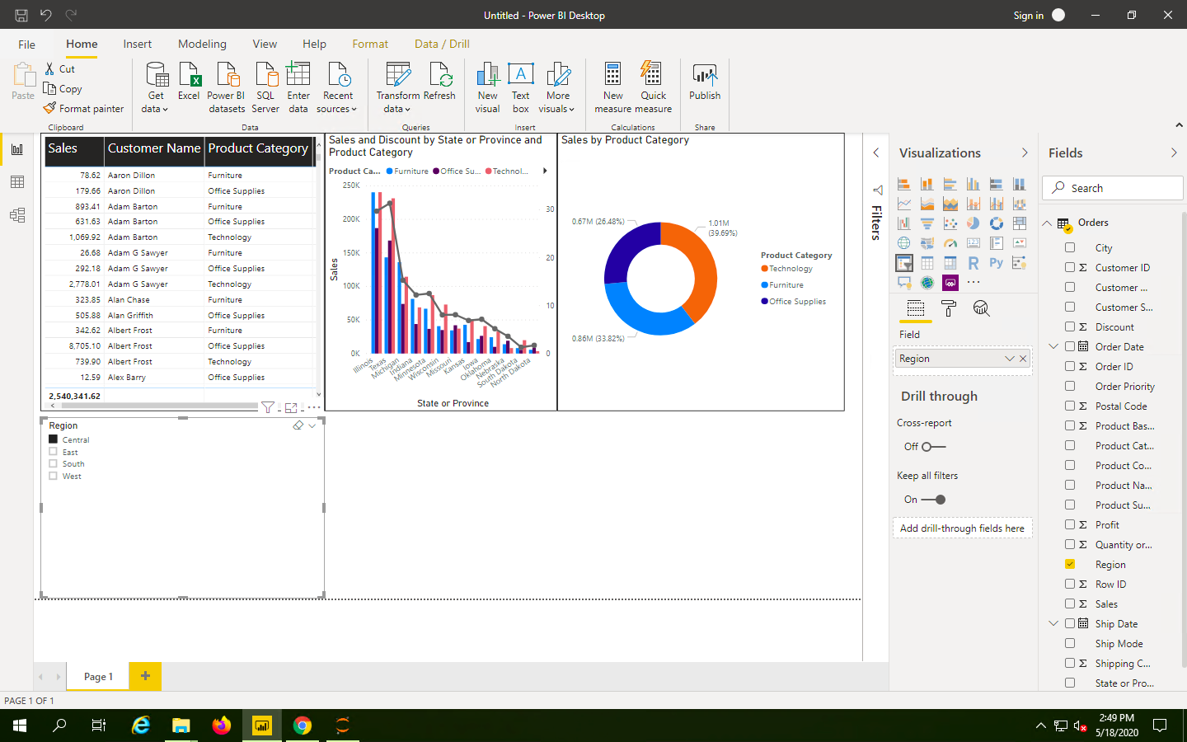

For East region, New York and Pennsylvania have the highest sales.

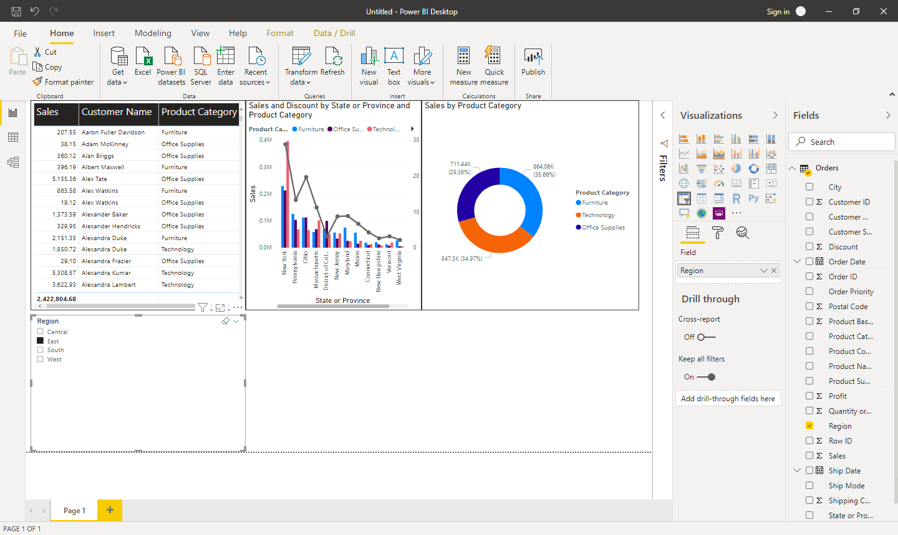

For South Region, Florida and North Carolina have the highest sales.

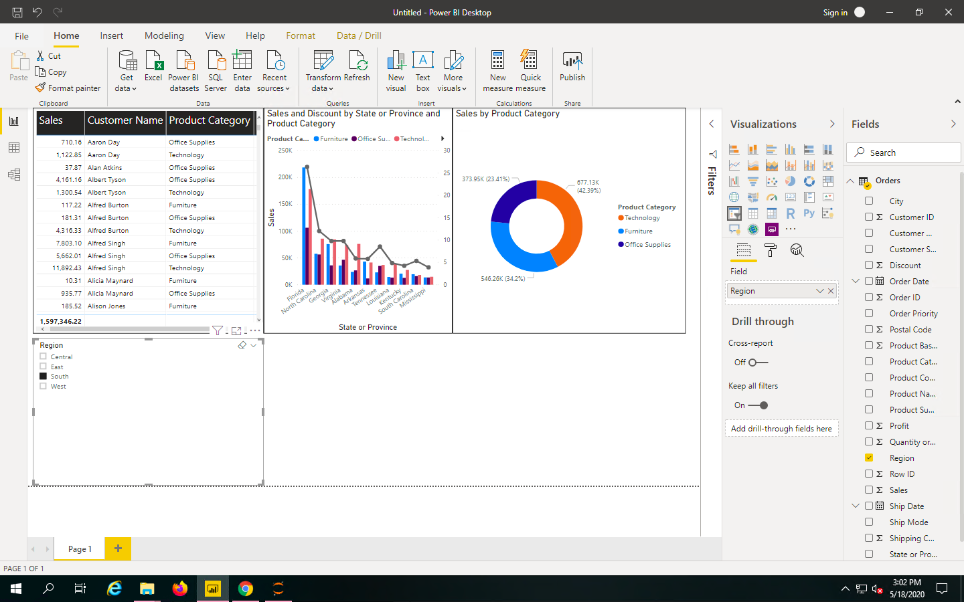

For West region, California and Washington have the highest sales.

